12th Sunday of Pentecost August 16, 2026
Prairieland Parish
As we unite in worship today, we extend a warm welcome to each one present. May we together experience the presence of God
+++++++++++++++++++++++++++++++++++++++++++++++++.
We Gather to Prepare Our Hearts to Meet Our Lord

Prelude
Welcome
Announcements

Call to Worship

When our requests for mercy from God first appear to not be received.

We must not lose faith in God. We know God hears our prayers but faithful requests will be answered in God’s time

Let us have the steadfast faith of the Canaanite woman to not leave God but continue to follow and patiently wait for the mercy of God

We ask you Heavenly Father for the strength to meet you on your terms and timeline. May our desire to have each request we make not be offered as an immediate want, but rather a prayerful request coupled with patience knowing you provide all we need. Amen.

Prayer of Confession
We know we are blessed by God to receive his wondrous mercies. Forgive us when we think our wants exceed our needs and our wanting to have our cries for mercy answered on our terms. Help us to have the patience to wait for your actions. Your love for us in not measured by how long it takes for our requests to be answered. Your love for us was proven by the sacrifice of your son Jesus. We ask for your mercy when we fail to keep the love of your son in our hearts first. Amen

Assurance of God’s care for us

Jesus did not neglect the Canaanite woman’s request. Her steadfast faith in knowing the wondrous mercy of God and not wanting to be without it shows what was in her heart. We thank you for all the actions of Jesus that are written and recorded for us to know the vastness of your love for us. When our patience runs short for your answers, we need to reflect on today’s passage for guidance on how to remain in your presence until your answer is revealed to us.

Praise Hymn UMH #707 Hymn of Promise

The Word of God

Gospel Lesson…………………………………………………………………………………Matthew 15: 21-28

The Word of God for the people of God! THANKS BE TO GOD

Children’s time

Faith Hymn UMH #714 I Know Whom I Have Believed

Message

Prayers for the People—The Lord’s Prayer

Offering/Doxology/Prayer

Departing Hymn UMH #710 Faith of Our Fathers

Departing words:

As we depart today to enter the mission field once we leave the walls of this church, let our observed faith be as obvious to all around us, just as the Canaanite woman displayed her faith.

POSTLUDE (you are welcome to remain to listen to the postlude).

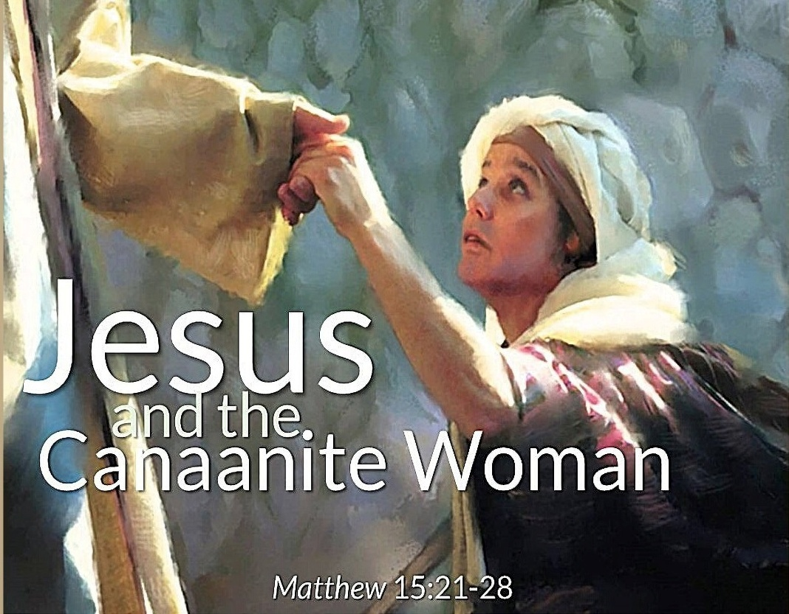

August 16, 2026

